Fault Diagnosis in Image-Based Visual Servoing with Eye-in-Hand Configurations Using Kalman Filter

Mien Van, Michalis Mavrovouniotis, *Member, IEEE*, Shuzi Sam Ge, *Fellow, IEEE*

*Abstract*—In this paper, the fault diagnosis (FD) problem in image-based visual servoing (IBVS) with eye-in-hand configurations is investigated. The potential failures are detected and isolated based on approximating parameters related. First, the failure scenarios of the visual servoing systems are reviewed and classified into the actuator and sensor faults. Second, a residual generator is proposed to detect the failure occurrences, based on the Kalman filter (KF). Third, a decision table is proposed to isolate the fault type. Finally, simulation and experimental results are given to validate the efficacy and the efficiency of the proposed fault diagnosis strategies.

*Index Terms*—Control of robots, Fault diagnosis, Image-based visual servoing, Kalman filter, Robot-vision systems.

# INTRODUCTION

V

isual servoing, has been applied extensively in robotics to enhance its intelligence and flexibility. The goal of this task is to calculate the control input that was applied to the robotic system so that the error between the predefined image features and a desired static reference can converge to zero. Generally, the categories of the visual servoing can be divided into three classes: 1) position based visual servoing (PBVS) [1], where the 3D data retrieved from the image features are used as the feedback to calculate the control input; 2) image-based visual servoing (IBVS) [2], where the direct 2D image features are used as the feedback to calculate the control input, and 3) hybrid visual servoing [3], where both 2D and 3D data is combined as the feedback. Among them, IBVS is widely applied due to it’s easy in implementation and robustness with measurement noise and model uncertainties [4]. In visual servoing system, there are two ways to configure the camera: 1) eye-in-hand configuration, where the camera is rigidly attached to the robot end-effector, 2) eye-to-hand configuration, where the camera is fixed in the workspace. Among them, eye-in-hand configuration is widely used because it provides high precise and workspace exploration [5-6]*.*

In the IBVS, the control input is computed based on the feedback of the difference between the current and desired image features. Thus, the system is working well only when all the desired features are extracted correctly. Toward this research direction, reliable feature extraction methods have been developed in computer vision [7]. In addition, reliable feature tracking methods have also been developed to enhance the robustness of feature tracking based on Kalman filter (KF) [8] or Particle filter (PF) [9], etc. However, the designed image features are not always correctly identified by these methods; some features may appear in or disappear from the image during visual servoing [10]. Generally, there are two sources that make the failures of the image feature extraction during visual servoing [10-12]: 1) whilst the camera is moving, some parts of the object, which contain the designed features, are out of the field of view (FOV) of camera, and 2) due to the environment noises (image noise, obstacles, target itself), some desired features will disappear (occlusion), or some undesired features will appear. The failure scenarios of the visual servoing due to the appearance/disappearance of the image feature are generally illustrated in Fig. 4, will be discussed later on. In this work, detecting failures of visual servoing system is focused on. Fault diagnosis (FD) has not been a focus of prior works on visual servoing, but there are a few examples that have been developed to avoid the designed image features being out of FOV of camera during visual servoing for both PBVS and IBVS [11]. In [12], a continuous control has been developed by weighting the displacement of the image features. In [13], a controller based on a switching between PBVS and backward motion has been developed. In [14], a randomized kinodynamic path planning algorithm has been developed to enhance the visibility of the camera and avoiding workspace obstacles during tracking. In [15], a probabilistic road map has been developed for path planning of visual servoing to enhance the visibility of camera. Other approaches to deal with the image feature occlusion during visual servoing are to combine multiple sensors [16]. Although the aforementioned approaches can reduce the appearance/disappearance of the image feature caused by the limitation of the FOV of camera or occlusion by obstacles, no report certainly guarantees that the image feature will not be moved out/in of the FOV of camera during visual servoing in a complex environment. In addition, the appearance/disappearance of the image feature due to the image noise has not yet been considered, in fact this failure usually presents in real applications.

It is obvious to figure out that the IBVS is working well when not only the designed features need to be extracted correctly but also the robot needs to be moved freely and correctly. However, several problems that make the robot wrong execution have been reported; for example the failures caused by kinematic singularity, joint limits, collision with obstacle [14], or failure of the robot components (actuator or encoder) [17], etc. In literature, several approaches have been developed to detect the internal robot system faults, such as actuators, components, and encoder faults [18]. However, there were no FD schemes developed for the robot that has been used in visual servoing. Recently, due to the sensitivity capability, the vision system has been applied for FD of robotic system based on the assumption that the camera signal has no failures [19]. However, this assumption is not usually valid in real applications due to the failures of feature extraction task mentioned above.

In summary, most of the previous approaches have just focused on increasing the visibility capability of the camera during visual servoing or detecting the faults of the internal robot components, there were no approaches in literature to review the failure scenarios of visual servoing system in depth and to develop a condition monitoring scheme to monitor the presence of such failures as well.

In this paper, FD problem for visual servoing is stated and classified into actuator and sensor faults. Then, we design a FD scheme to detect and isolate the faults. Detection and identification tasks are activated by approximating parameters related to potential failures based on the KF algorithm. The KF is used here because it has a good capability to approximate the Gaussian noise system parameters [8, 20-21], and has been successfully applied for design of state estimation and condition monitoring [22].

The major contributions of this paper can be summarized as follows:

* A dynamic model of the visual servoing is derived.
* Popular fault scenarios in IBVS with eye-in-hand configuration are declared and classified into actuator and sensor faults.
* A fault detection scheme is proposed to detect the faults.
* A decision table is proposed to isolate the actuator and sensor fault types.

The rest of this paper is organized as follows. In section II, an IBVS and its model are described. In section III, fault scenarios for visuals servoing are reviewed. The proposed fault detection and isolation scheme is described in section IV. In section V and VI, simulation and experimental results are shown to verify the effectiveness of the developed FD scheme. In section VII, we provide conclusions and future works.

# Image-based visual servoing and Its model

Let the axes of the camera frame  attached at the center of the camera  be denoted by . The  are the axes of the image frame , and  denotes the center of the image, as depicted in Fig. 1. Note that the  axis of the camera frame is perpendicular to the image plane traversing . In this configuration, the relations between a set of  fixed 3D points ,  expressed in the camera frame and the corresponding 2D image feature ,  are given by [1]:

 (1)

where  is the focal length of the camera. Thus, the effect of



Fig. 1. The geometric model of a pinhole camera [21].

the camera motion of the feature coordinates at the image plane is given by:

 (2)

where



is the interaction matrix, and  denotes the spatial velocity of the camera, in which  denotes the instantaneous linear velocity and  denotes the instantaneous angular velocity of the camera frame.

Let the pose of the robot end-effector in the robot base frame be denoted by   and the image feature measurements be represented by . Then, the relation between the derivative of  and  is formulated by

 (3)

where  is the image Jacobian,  is the transformation matrix that converts the velocities expressed in the camera frame to the velocities expressed in the robot base frame.

The dynamic model (3) can be represented by the following state space model if we consider a local model based on the interaction matrix [21]:

 (4)

where  denotes the system state vector,  is the input signal,  represents the system uncertainties, which consists of the error when converting the (3) to (4), the vibration of the robot end-effector during moving, etc.,  refers to Gaussian noise with expected value  and covariance , and

,  (5)

 (6)

where  is the identity matrix.

In this paper, the control law is designed based on the standard algorithm for IBVS [1].



Fig. 2. Block diagram of IBVS control system.

# The Considered Fault Scenarios

In this section, fault scenarios of the IBVS visual servoing are declared. The overall control system of an IBVS is illustrated in Fig. 2. From Fig. 2, the IBVS controller is computed on the error between the target feature and actual feature, which is extracted from the image information acquired by camera. Thus, if we consider the motion of camera and feature extraction task as the plant of the system dynamics, as shown in Fig. 2, the input (actuator) and output (sensor) can be declared as in Fig. 2. In this paper, we consider two main classes of failures in the visual servoing systems: incorrect camera motion and incorrect image features extraction. Based on the classification of the fault type in [23], for the dynamic system (4), the incorrect camera motion can be considered as actuator fault, and the failures of image feature extraction task can be referred to sensor fault.

## Actuator faults

When an actuator fault occurs, the actual input velocity applied to the robot end effector is different to the input commanded by the IBVS controller. In this case, the actual velocity control input consists of the nominal velocity calculated by the IBVS controller defined in (2), , and the input fault, , i.e., . In practice, the source of this kind of fault usually comes from the robot manipulator, such as kinematic singularity, joint limits, failure of the robot system (actuator, components or encoder [17-18]) or collision with obstacle [14], etc. Fig. 3 illustrates some kind of actuator faults.

In the presence of an actuator fault, the visual dynamic system (4) can be written as

 (7)

Here, the form of the actuator fault is modeled by

 (8)

where  is the unknown time of occurrence of actuator fault.

## Sensor faults

In the presence of sensor faults, the visual servoing control system fails to determine the exact displacements of the designed image features. In this case, the actual displacement of the extracted image features is expressed by , where  is the true but unknown displacement of the image feature output (i.e. the image feature displacements), while  is the vector of the fault signals acting on it. In practice, this kind of failure can be caused by the appearance/disappearance of a feature or the

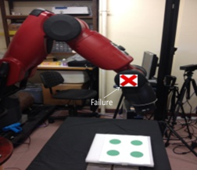

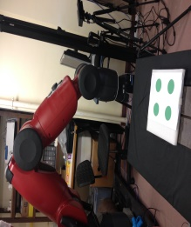

a)

b)

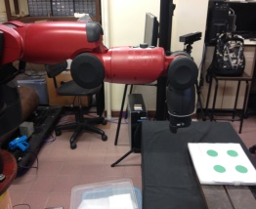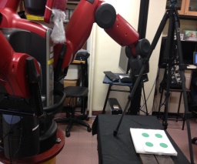

c)

d)

Fig. 3. Illustrated of actuator faults in visual servoing: a) normal operation, b) robot actuator fault, c) joint limit, and d) collision with obstacle.

1

3

2

4

5

1

3

2

4

1

3

2

b)

a)

1

3

2

4

d)

c)

Fig. 4. Illustrated of sensor fault scenarios: a) normal extracted feature, b) one designed feature disappear, c) one undesired feature appear, d) bias fault in feature extraction.

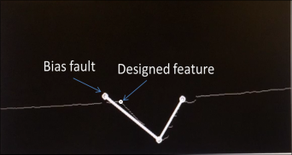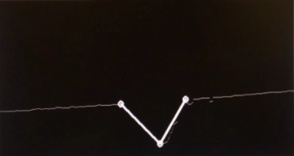

a)

b)

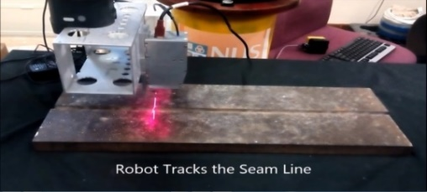

c)

Fig. 5. Illustrated of bias fault in weld seam extraction: a) normal feature extraction, b) bias fault, and c) welding robot system.

change of a feature due to noise or reflection. The failure scenarios of sensor (feature extraction task) are illustrated in Fig. 4. Fig. 4a) illustrates the visual servoing in normal operation; the system extracts the designed image feature points correctly. Fig. 4b) illustrates a failure scenario when a feature point is disappearing. Fig. 4c) illustrates a failure scenario when the vision system extracts an incorrect feature point (feature point 5), which has the similar property with a designed feature (feature point 4), while the designed feature point 4 is occluded. In this situation, the visual servoing controller will misunderstands that the feature point 5 is a true designed image feature point instead of the feature point 4. Fig. 4d) describes a popular sensor bias fault; the vision system reads a wrong displacement of the image feature. This kind of failure can be found widely in real application; for example in weld seam extraction of welding robot, shown in Fig. 5. In Fig. 5a), three designed feature points are extracted correctly for V-groove welding type. However, in Fig. 5b), due to the image noise, the vision system cannot determine the true designed image feature point instead the noise feature point is extracted. The full video that describes a bias fault in weld seam extraction of welding robot are described in Appendix A. It is clear to recognize that the failure due to the disappearance of the feature point illustrated in Fig. 4b) can be detected easily by controller system based on the prior knowledge about the designed features. However, the failure scenarios illustrated in Fig. 4c) and Fig. 4d) are difficult cases, the traditional controller may not able to detect this kind of fault since it may misunderstands that the noise feature is the designed feature. The imprecise sensor data will generates incorrect camera motion and consequently degrades the system performance seriously. Thus, it is important to detect and isolate the effects of the fault.

Under the effects of time varying bias due to the sensor faults, the system dynamics of the visual servoving is changed. To represent this change, the function  is used in this paper. That is, in the presence of sensor faults, the system dynamics can be described by

 (9)

where the sensor bias is modeled as

 (10)

where  is the unknown time of occurrence of sensor fault.

# Fault Detection and Isolation

## Fault Detection

To detect the fault, parameters related to potential failures are estimated. Since the presented state space model in (4) contains noises, the KF is used in this paper to handle the noises. The estimation of the state vector based on KF is updated by using the two groups of equations [8, 20-21].

1) *Time update*: Compute a priori quantities for iteration 

 (11)

where  and  are the estimation error covariance matrix at time  and error covariance matrix at time , respectively.

2) *Measurement update*: Use the measurement available at time  to enhance the accuracy of the prediction 

 (12)

Thereafter, the estimated output is calculated as

 (13)

In order to detect a fault, residual and threshold, which is denoted by  throughout the text, need to be suitable selected [23]. These parameters are chosen such that the system can distinguish between normal operation and fault operation clearly. In this paper, the KF estimation error  defined in (14), which is defined as the different between the actual designed image feature output and the KF output estimate, is chosen as the residual.

 (14)

Because the KF eliminates the Gaussian white noise effectively, from (9) and (11), the residual  tends to approximate the zero-mean white sequence produced by the Kalman filter, , and the uncertainty , i.e., , when the system in normal operation. It is assumed that the system uncertainties and noises are bounded by , where  is a constant. In practice, the bound value of the system uncertainty and noise are usually obtained by experiments. Since , one way to estimate the system uncertainty and noise values is to calculate the residual  when the system in normal operation. This method is employed in this paper.

In the visual servoing, *n* designed image features are captured by one camera. By using suitable feature extraction techniques, the displacement of each feature point is calculated. According to section IIIB, the displacement of a feature point does not affect to other features. Thus, it is reasonable to assume that *n* distinguishable virtual sensors are used to measure *n* distinguishable designed image features. The state condition of a feature point is represented by two state variables *u* and *v*. To facilitate in detecting fault of a feature point, the information of two state variables  and  are converted to the state variable  by introducing the following root mean square estimation error:

 (15)

where  and  represent the KF estimation error of the state variables  and  of the feature point , respectively, and  is used to represent the KF estimation error of the feature point .

Then, the residual vector is defined as

 (16)

where  is a chosen threshold.

TABLE I

Fault-Signature Table

|  |  |  |  |  |  |  |
| --- | --- | --- | --- | --- | --- | --- |
| Fault |  |  |  |  | … |  |
| None | 0 | 0 | 0 | 0 | … | 0 |
| Sen. 1 | 1 | 0 | 0 | 0 | … | 0 |
| Sen. 2 | 0 | 1 | 0 | 0 | … | 0 |
| Sen. 3 | 0 | 0 | 1 | 0 | … | 0 |
| Sen. 4 | 0 | 0 | 0 | 1 | … | 0 |
| … | … | … | … | … | … |  |
| Sen. n | 0 | 0 | 0 | 0 | … | 1 |
| Actuator | 1 | 1 | 1 | 1 | … | 1 |

**Robustness property**: the robustness property of a fault detection scheme is defined as its capability to prevent a false alarm due to the effects of the system uncertainties and noise before the fault occurs. Since  , where  and  represent the effects of noises and uncertainties in the variable  and  of dynamic system, respectively, to guarantee the robustness of the fault detection scheme,  is chosen as the threshold. Faults are declared when the residual, estimation error (), overshoots its corresponding threshold . In normal operation, the observer state  approximates the true state  with a small error  due to the uncertainties and noises, i.e.,  and  . However, when a fault occurs, the residual  is likely to become larger and overshoots the predetermined threshold , i.e.,  and , the fault decision will be made accordingly.

**Fault sensitivity analysis**: the sensitivity property of a fault detection scheme is to determine the set of faults such that the system can detect them even in the weak condition. When a fault occurs, the residual is approximated by , where ,  and  represent the effects of the actuator or sensor faults in the state variables  and  of the system dynamics, respectively. Using triangle inequality, we obtain  . Therefore, when , the inequality  is always satisfied. This means that when a fault with magnitude  occurs, the residual overshoots the threshold , and thus the fault is detected.

## Fault Isolation

After a fault is detected, it is necessary to isolate its location for easy in fault accommodation or maintenance. In literature, the popular method used to isolate the fault is to use multiple observers, i.e, one observer is used to isolate one fault type [23]. However, the approach increases the computation time



a)



b)



c)

Fig. 6. Tracking performance of visual servoing in normal operation. a) image space, b) control inputs, c) image error.

of the fault diagnosis system. In this paper, a simple rule is designed to isolate the actuator and sensor faults based on the relation in motion between the actuator and the sensors in the visual servoing system. In the eye-in-hand IBVS, the displacements of the designed image features are dependent on the camera motion, while the extractions of the feature points are independent. It means that the designed image features are dependent on the actuator motion but independent in extraction. Thus, the failure of a feature point does not affects much to the displacement of other features, while the failure of the actuator will affects to the displacement of all the feature points. Thus, a decision rule can be defined as in Table I to isolate the fault types, wherein  is defined as in (16). The isolation of a fault is then performed by comparing the binary detection vector  defined in (16) with the subsequent fault signature Table I.

**Remark**: This paper does not consider the heavy sensor fault case, where all the sensors are failed at the same time. In this case, according to Table I, the control system will isolate a wrong actuator fault instead of the sensor faults, but in real application such consistency is rarely occurred.

# Simulation Results

In order to verify the developed fault diagnosis system for visual servoing, we have simulated an image-based visual servoing. The objective is to position the camera in a desired



a)



b)

Fig. 7. Kalman filter estimation error when the system in normal operation and the selected threshold values. Blue line for , red line for  and green line for (note that b) is just an zoom out of a)).

position in a relation to the target, which is represented by four points. The size of the image is 1000x1000 pixel. The dashed and dot-dashed lines in the image space in Fig. 6a) are the coordinate of the four points in the initial image and desired image, respectively. For KF, using a trial-and-error procedure, the parameters are set as  and . To verify the developed algorithm, the visual servoing system is considered in three working scenarios: normal operation, sensor fault and actuator fault. On the other hand, because the residual and the corresponding chosen thresholds are dependent on the system uncertainties and noises as the analysis in section IV, the system is modeled with different level of measurement noise conditions ,  and , where  is the mean value of the noises.

## Visual Servoing in Normal Operation

The tracking performance of the visual servoing system in normal operation for the case  is shown in Fig. 6 (the results for  and  are not shown to reduce the length of the paper). The result shows that the system provides a good tracking performance. The KF estimation errors for the three cases, ,  and , are shown in Fig. 7. It can be seen from Fig. 7 that the KF estimation errors of all the feature points are close to zero after a few iterations when the system in normal operation. It is obvious to see that the bigger the system noises are, the bigger the residuals obtain. The results are identical to the analyzed theoretical in section IV. It can be assumed that the unknown faults only occur after the KF estimation errors converge close to zero (after the iteration 5 in Fig. 7). Then, from analysis in section IVA, the thresholds, , are selected as shown in Fig. 7 for the three cases (blue line), (red line) and (green



a)



b)

Fig. 8. Tracking performance of visual servoing when the failures existed in the feature points 3 and 4. a) control inputs, b) Image error.



Faults are detected and isolated

Fig. 9. Kalman filter state estimation error when the failures existed in the feature points 3 and 4 when .



Faults are detected and isolated

Fig. 10. Kalman filter state estimation error when the failures existed in the feature points 3 and 4 when .



Fault is detected and isolated

Fig. 11. Kalman filter state estimation error when the failures existed in the feature points 3 and 4 when .

line). A fault is detected and isolated whenever the residual exceeds its corresponding selected threshold .



a)



b)

Fig. 12. Tracking performance of visual servoing when the failures existed in the actuator. a) control inputs, b) Image error.



Fig. 13. Kalman filter state estimation error when the failures existed in the actuator.

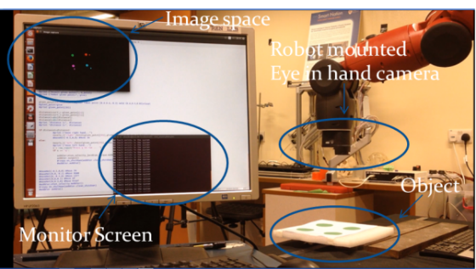

Fig. 14. Experiment setup for image-based visual servoing system.

## Sensor Faults

It is assumed that the feature points 3 and 4 are incorrectly extracted by visual servoing at the iteration 25. It means the displacement location of the features 3 and 4 are changed by adding a bias fault . This kind of failure, illustrated in Fig. 4d) and 5b), can be used to represent the appearance (illustrated in Fig. 4c)) or disappearance (illustrated in Fig. 4b)) or bias fault (illustrated in Fig. 4d)) of the features 3 and 4 in general. For example, when the feature points 3 and 4 are occluded, the fault function can be described as . The sensitivity of the FD system to the assumed fault for the three different noise conditions, ,  and , are also examined. The tracking performances of the visual servoing system under the effect of the fault when  are shown in Fig. 8. The figure indicates that the faults diminish



a)



b)



c)

Fig. 15. Tracking performance of visual servoing when the visual servoing system in normal operation. a) Image space, b) control inputs, c) Image error.



Fig. 16. Kalman filter estimation error when the visual servoing sytem in normal operation.

1

2

3

4

1

2

3

5

4

b)

a)

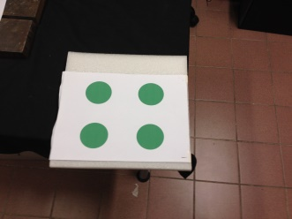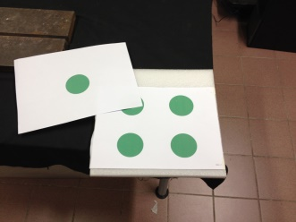

Fig. 17. Simulate an bias fault for experiement. a) normal extraction, b) bias fault.

the performance of the whole visual servoing system. This makes the robot, in a heavy fault case, possible out of control. Thus, fault diagnosis is very important to isolate the effects of the faults. The responses of the KF estimation errors to the assumed faults for the visual servoing system in the three



a)



b)

Fig. 18. Tracking performance of visual servoing when the failures existed in the sensor (feature point 4). a) control inputs, b) Image error.

cases ,  and  are shown in Figs. 9, 10 and 11, respectively. For the system with , the failures of the points 3 and 4 have been detected and isolated correctly and obviously, as shown in Fig. 9. For the system with , the failures of the points 3 and 4 are also correctly detected and isolated, but not obvious compared to the case , as shown in Fig. 10. For the system with , only the failure of the feature point 3 is detected and isolated, while the failure of the feature point 4 cannot be detected, as shown in Fig. 11. Thus, it can be concluded that the sensitivity of the FD scheme is decreased according to the increasing of level of noises and uncertainties of the system. Fortunately, in the system with heavy noise, the effect of the failure of the point 4 is weak and it does not affect much to the performance of the whole visual servoing system. As such, the effects of the assumed fault in the feature point 4 can be considered as same as the effects of the measurement noise.

## Actuator Faults

To simulate the actuator fault in the visual servoing system, the motion of the robot end-effector is assumed to move incorrect as the command of the IBVS controller. To simulate this failure situation, we simply add a fault function to the input velocity command of the robot end-effector at the iteration 25. This fault function can be used to represent the faults caused by the source of the robot system in general. Because the sensitivity of the FD scheme to the actuator fault is similar to the sensor fault case, FD for the system with the noise  is examined only (to reduce the length of the paper). The responses of the visual servoing system under the assumed actuator fault are shown in Fig. 12. From the figure we can see that the system performance is decreased significantly due to the effect of the actuator fault. The KF estimation errors, shown in Fig. 13, indicate that the actuator fault was existed in the system according to the decision rule defined in Table I. Thus, the actuator fault has been detected and isolated correctly.

# Experimental Results

In this section, experimental results are presented for a configured IBVS with eye-in-hand camera. To validate the proposed FD system, it has been implemented for visual servoing with a Baxter industrial robot [24]. The Baxter is a



Fig. 19. Kalman filter estimation error when the failures existed in the sensor 4 (feature point 4).



a)



b)

Fig. 20. Visual servoing tracking performance when the failures existed in the actuator. a) control inputs, b) Image error.

new collaborative industrial robot developed by Rethink Robotics. The Baxter has two arms with 7-DOF for each and eye-in-hand camera equipped in each hand. In this paper, the left-arm and left-hand camera were used to execute the experiment. The camera images were sent at 30 fps (frame/s) to the host PC running under Linux. The images had the size of 640x400 pixels and had an effective focal length of 1.2mm.

In this paper, the visual target is composed of four points, which is determined by the center of four green circles. Fig. 14 illustrates the experiment setup used in this paper. The parameters for the KF are set as  and . The values are selected based on the trial and error evaluation. In order to verify the detection and isolation capability of the proposed FD method, we also consider the visual servoing system in three working scenarios: normal operation, sensor fault and actuator fault. In each experiment, the robotic arm is controlled to allocate to a desired pose regulated by four feature points.

## Visual Servoing in Normal Operation

Fig. 15 shows the tracking performance of the visual servoing system in normal operation. It can be seen from Fig. 15 that the robot tracks the predefined image feature points with small error. The corresponding KF estimation errors, shown in Fig. 16, are quickly convergent close to the system uncertainty and noise values after a few iterations. To isolate the normal condition and the fault condition, the thresholds values, , are then selected as described in section IV and are shown in Fig. 16 (red line).



Fig. 21. Kalman filter estimation error when the failures existed in the actuator.

## Sensor faults

To simulate the sensor fault scenario, a bias fault situation like the bias fault in weld seam extraction shown in Fig. 5 is modeled; the vision system reads wrong displacement of the feature point 4. To simulate this scenario a white paper is used to cover the feature point 4 to change its displacement at around the iteration 28, as shown in Fig. 17. The response of the visual servoing system under the effect of the fault is shown in Fig. 18. It can be seen from Fig. 18 that the system performance is reduced due to the effect of fault. The responses of the KF estimation errors, shown in Fig. 19, verify that the fault has been detected and isolated successfully.

## Actuator faults

To simulate the actuator fault, a fault signal  is added into the velocity control input of the robot end-effector at the iteration 28. The full video that describes the experiment setup for the actuator fault is described in Appendix B. The behavior of the visual servoing system under the effect of the generated actuator fault is shown in Fig. 20. Particularly, Fig. 20a) indicates that the robot velocity control input is suddenly changed due to the effect of the fault. The corresponding feature errors are shown in Fig. 20b). It is obvious to see that all the feature errors become larger when the actuator fault occurs. All the KF estimation errors, shown in Fig. 21, overshoot the corresponding predefined threshold values , indicating that the actuator fault has been existed in the system according to the decision rule in Table I.

From the presented results it can be concluded that, in our experimental evaluation, the proposed fault diagnosis scheme has detected and isolated the faults effectively and there were no false alarm or missed detection.

# Conclusion

The failure scenarios of visual servoing have been reviewed in this paper. The fault diagnosis system for monitoring the failures of a vision feedback robotic control system has been designed based on Kalman filter. The residuals and thresholds have been effectively derived so that the fault detection scheme can provide a correct decision when a fault occurs. To isolate the actuator and sensor faults, a decision table has also been proposed. Simulation and experiment results have shown the correct fault detection and isolation of the proposed fault diagnosis algorithm. After the fault is detected and isolated, it is desired that the visual servoing control system should be reconfigured according to the obtained fault information to reduce the effects of the fault in the system. Fault tolerant control for visual servoing system will be a major part of the future work.

Appendix A

The video that describes the failure of weld seam extraction can be found in the experiment in the link:  <http://youtu.be/3qF6cltZw0I>. In this experiment, the sensor system consists of the following hardware: a CCD camera, a red stripe laser and a reflector. The sensor system setup is shown in Fig. 22. The camera is set up perpendicular to the workpiece surface with the projected laser stripe, which is obtained by using the laser projected to the reflector, oriented toward the camera view at an angle of approximately 45 degree.

The camera takes an image which contains the information about the laser projected onto the workpiece and possible distortions caused by noise. In normal working condition, the three designed feature points are correctly extracted for V-groove welding type by means of suitable image processing algorithm, as shown in Fig. 5a). However, due to the image noise, the vision system cannot determine the true designed image feature point instead the noise point is extracted, as shown in Fig. 5b).

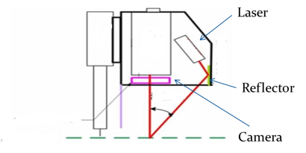 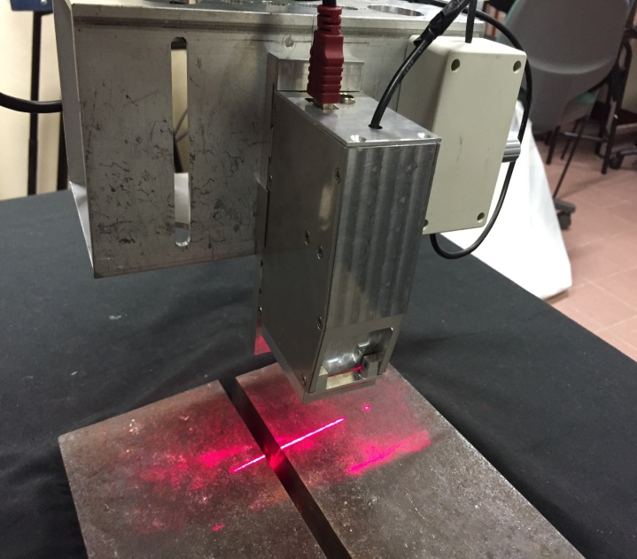

b)

a)

Fig. 22. Architecture of sensor fusion used in the experiment for weld seam extraction. a) Sensor configuration, b) hardware configuration.

Appendix B

The video that describes the experiment setup for actuator fault is described in the link: <https://www.youtube.com/watch?v=tUuBtxNZYks>. In the experiment, the fault signal is generated to the Baxter by simply adding a fault signal  into the velocity control input of the end-effector at the iteration 28.

In the video, the behavior of the robot end-effector when the systems in normal operation and in the actuator fault operation are compared. From the video, it can be seen that the robot in the actuator fault operation tracks the object as in normal operation until the fault is generated. At the time the actuator fault is generated, the position of the robot end-effector is changed accordingly. And thus, the fault diagnosis system can detect the failure.

References

1. F. Chaumette, S. Hutchinson, “Visual servoing control, part I: Basic approaches,” *IEEE Robotics and Automation Magazine,* vol. 13, no. 4, pp. 82-90, 2006.
2. M. Keshmiri, W. F. Xie, and A. Mohebbi, “Augmented image-based visual servoing of a manipulator using acceleration command,” *IEEE Trans. Ind. Electron.,* vol. 61, no. 10, pp. 5444-5452, 2014.
3. E. Malis, F. Chaumette, and S. Boudet, “2(1/2)d visual servoing,” *IEEE Robot. Autom.,* vol. 15, no. 2, pp. 238-250, Apr. 1999.
4. A. Hajiloo, M. Keshmiri, W. F. Xie, T. T. Wang, “Robust online model predictive control for a constrained image based visual servoing,” *IEEE Trans. Ind. Electron.*, vol. 63, no. 4, pp. 2242-2250, Apr. 2016.
5. I. Siradjuddin, L. Behera, T. M. Mcginnity, S. Coleman, “Image-based visual servoing of a 7-DOF robot manipulator using an adaptive distributed fuzzy PD controller, *IEEE Trans. Mechatronics.*, vol. 19, no. 2, pp. 512-523, 2014.
6. M. Keshmiri, W. F. Xie, A. Mohebbi, “Augmented Image-based visual servoing of a Manipulator using acceleration command,” *IEEE Trans. Ind. Electron.*, vol. 61, no. 10, pp. 5444-5452, 2014.
7. L. Baroffio, M. Cesana, A. Redondi, M. Tagliasachi, S. Tubaro, “Coding visual features extracted from video sequences,” *IEEE Trans. Image Process.,* vol. 23, no. 5, pp. 2262-2276, 2014.
8. S. Y. Chen, Kalman filter robot vision: A survey, *IEEE Trans. Ind. Electron.*, vol. 59, no. 11, pp. 4409-4420, 2012.
9. C. Chen, D. Schonfeld, “A particle filtering framework for joint video tracking and pose estimation,” *IEEE Trans. Image Process.,* vol. 19, no. 6, pp. 1625-1634, 2010.
10. Y. Fang, X. Liu, X. Zhang, “Adaptive active visual servoing of nonholonomic mobile robots,” *IEEE Trans. Ind. Electron.*, vol. 59, no. 1, pp. 486-497, 2012.
11. H. T. Nguyen, A. W. M. Smeulders, "Fast occluded object tracking by a robust appearance filter," *IEEE Trans. Pattern. Analy. Machine. Intel.*, vol. 26, no. 8, pp. 1099-1104, 2004.
12. N. G. Aracil, E. Malis, R. A. Santonja, C. P. Vidal, “Continuous visual servoing despite the changes of visibility in image features,” *IEEE Trans. Robot.*, vol. 21, no. 6, pp. 1214-1220, 2005.
13. G. Chesi, K. Hashimoto, D. Prattichizzo, and A. Vicino, “Keeping features in the field of view in Eye-In-Hand visual servoing: A switch approach,” *IEEE Trans. Robot.*, vol. 20, no. 5, pp. 908-913, 2004.
14. M. Kazemi, K. K. Gupta, M. Mehrandezh, “Randomized kinodynamic planning for robust visual servoing,” *IEEE Trans. Robot.*, vol. 29, no. 5, pp. 195-200, 2010.
15. M. Baumann, S. Leonard, E. A. Croft, J. J. Little, “Path planning for improved visibility using a probabilistic road map,” *IEEE Trans. Robot.*, vol. 26, no. 1, pp. 1197-1211, 2013.
16. V. Lippiello, B. Siciliano, L. Villani, "Position-based visual servoing in industrial multirobot cells using a hybrid camera configuration," *IEEE Trans. Robot.*, vol. 23, no. 1, pp. 73-86, 2007.
17. F. Caccavale, A. Marino, G. Muscio, F. Pierri, "Discrete-time framework for fault diagnosis in robot manipulators," *IEEE Trans. Control Syst. Technol.*, vol. 21, no. 5, pp. 1858-1873, 2013.
18. M. Van, S. S. Ge, H. Ren, "Finite Time Fault Tolerant Control for Robot Manipulators Using Time Delay Estimation and Continuous Nonsingular Fast Terminal Sliding Mode Control," in *IEEE Transactions on Cybernetics* , vol.PP, no.99, pp.1-13, doi: 10.1109/TCYB.2016.2555307, 2016
19. L. M. Capisani, A. Ferrara, P. Pisu, "Sliding mode observers for vision-based fault detection, isolation and identification in robot manipulators," *American Control conference*, Baltimore, MD, pp. 4540-4545, 2010.
20. F. Auger, M. Hilairet, J. M. Guerrero, E. Monmasson, T. O. Kowalska, S. Katsura, "Industrial applications of the Kalman filter: A review," *IEEE Trans. Ind. Electron.*, vol. 60, no. 12, pp. 5458-5471, 2013.
21. J. Ernesto Spolanes, L. Armesto, J. Tornero, V. Girbes "Improving image-based visual servoing with reference features filtering," *IEEE International Conference on Robotics and Automation*, pp. 3083-3088, 2013.
22. S. Huang, K. K. Tan, T. H. Lee, "Fault diagnosis and Fault tolerant control in linear drives using the kalman filter," *IEEE Trans. Ind. Electron.*, vol. 59, no. 11, pp. 4285-4292, 2012.
23. Z. Gao, C. Cecati, S. X. Ding, "A survey of fault diagnosis and fault-tolerant control techniques Part I: Fault diagnosis with model-based and signal-based approaches," *IEEE Trans. Ind. Electron.*, vol. 62, no. 6, pp. 3757-3767, June 2015.
24. C. Fitzgerald, "Developing baxter," *International Conference on Technologies for Practical Robot Applications.*, pp. 1-6, Woburn MA, 2013.